Introduction
Stellar is designed to make it easy for developers to issue digital assets and build applications that take advantage of a public distributed ledger that allows for near-instant payments and universal currency conversion.
Stellar is an open-source network for currencies and payments. Stellar makes it possible to create, send and trade digital representations of all forms of money—dollars, pesos, bitcoin, pretty much anything. It’s designed so all the world’s financial systems can work together on a single network.
Stellar has no owner; if anything it’s owned by the public. The software runs across a decentralized, open network and handles millions of transactions each day. Like Bitcoin and Ethereum, Stellar relies on blockchain to keep the network in sync, but the end-user experience is more like cash—Stellar is much faster, cheaper, and more energy-efficient than typical blockchain-based systems.

What is Stellar for?

The Stellar network launched in 2014. Since then it’s processed more than 450 million operations made by over 4 million individual accounts. Large enterprise companies and companies as small as single-dev startups have chosen Stellar to move money and access new markets.
From the beginning, Stellar has been cryptocurrency-adjacent, but the software has always been intended to enhance rather than undermine or replace the existing financial system. Whereas, say, the Bitcoin network was made for trading only bitcoins, Stellar is a decentralized system that’s great for trading any kind of money in a transparent and efficient way.
The Stellar network has a native digital currency, the lumen, that’s required in small amounts for initializing accounts and making transactions (you can read more about that here) but, beyond those requirements, Stellar doesn’t privilege any particular currency. It’s specifically designed to make traditional forms of money—the money people have been spending and saving for centuries—more useful and accessible.
For example, here’s what you can do with Stellar. You can create a digital representation of a U.S. dollar—on Stellar you’d call this a “dollar token”—and you can tell the world that whenever someone deposits a traditional dollar with you, you’ll issue them one of your new tokens. When someone brings that “dollar token” back to you, you promise to redeem it in turn for one of the regular dollars in that deposit account. Essentially, you set up a 1:1 relationship between your digital token and a traditional dollar. Every one of your tokens out in the world is backed by an equivalent deposit. So while people hold the tokens, they can treat them just like traditional money, because they know that they’re exchangeable for traditional money in the end.
‍
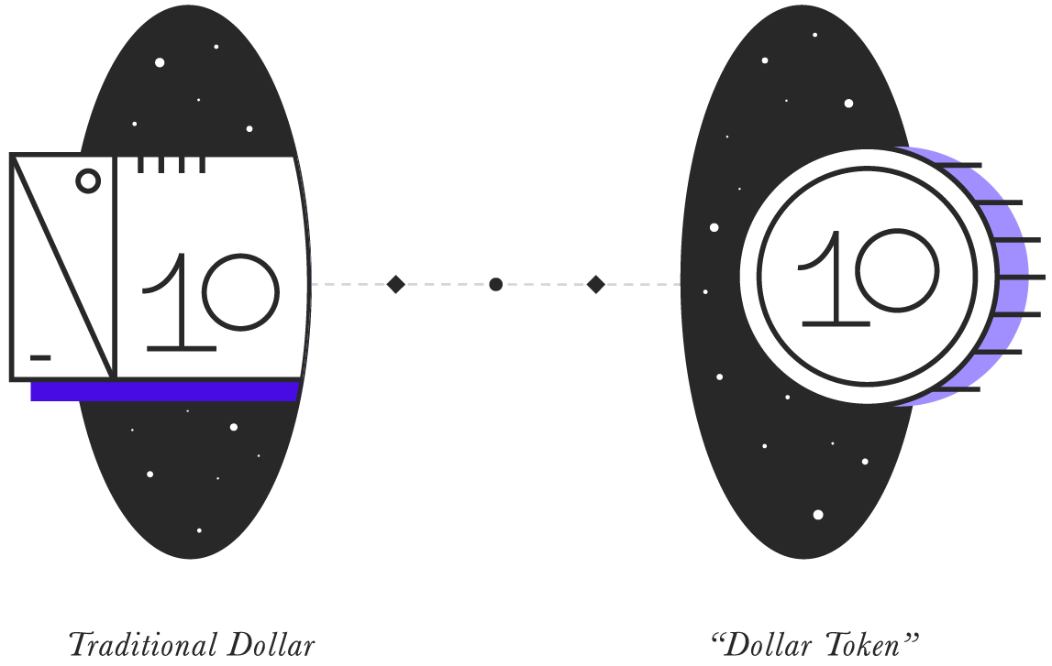
This might seem unexceptional—issuing electronic credits for dollars is basically what any local American bank does thousands of times a day. But in a global system this 1:1 promise of a token for a currency has important implications. For instance, no matter how a token moves through the economy, the underlying dollars never leave that bank account in the United States. So suppose someone loans their tokens to someone else, who then uses them to buy a car. No bank has to settle the purchase or approve the loan. And furthermore, it doesn’t matter if the seller of the car lives in Mexico or Singapore or anywhere, they can still own the tokens and can trade them however they please. The Stellar network makes money borderless.
Digital dollar tokens also mean people all over the world can own, buy, and sell the value of a dollar without themselves having a U.S. bank account. A Venezuelan can hold some of his family’s net worth in dollars. A Filipino expat can send dollars back home, and the recipient can hold them, safely and digitally, until she’s ready to exchange. An American company can pay a Mexican vendor in dollars, and the vendor can pay its suppliers in turn, with a five-second, rather than a five-day, wait to settle. Because the dollars represented by the digital token never actually move as the value changes hands, these transactions sidestep the friction and expense of the current banking system.
This exact dollar token example is in fact live on Stellar right now, implemented by a company called AnchorUSD—thousands of dollars of value moves quickly and cheaply through their USDx token each day. Of course, Stellar works for any currency, not just dollars. And when you add peso tokens, naira tokens, yuan tokens, pound tokens, bitcoin tokens, euro tokens and everything else, you have a truly unified monetary system that keeps the best parts of what exists today.

Stellar Lumens
Stellar was made to support digital representations of any currency, but it also has its own built-in token, called the lumen, created to fill a special role in the network. By design, Stellar requires that each account hold a small number of lumens at all times.
This lumen requirement is modest—a few is more than enough for most accounts. The full technical details are covered in Stellar’s docs, but, below, we explore some high-level concepts.

Why does Stellar require lumens?
The need for lumens arose out of the fundamental design of Stellar’s ledger system. Simply put, it’s too easy to use. Without some nominal barrier or cost, the ledger could become filled with spam or nonsense, or used as a kind of arbitrary database system. These outcomes would defeat the intent behind Stellar: to be a fast, efficient payments system.
To solve this, we needed to introduce just the slightest bit of friction to deter bad or frivolous actors. Imposing a minimum balance on each account and a very small per-transaction fee were chosen as these deterrent costs. Right now, the minimum balance is 1 lumen and the minimum per-transaction fee is 0.00001 lumen. These are small enough to keep Stellar widely accessible, but big enough to discourage large-scale bad behavior.
Since Stellar is a universal system for digital money, we could’ve allowed people to pay these costs in dollars, pesos, yuan or anything else. But we felt none of these were appropriate. First, we didn’t want the network to “prefer” any particular national currency—if Stellar used dollars, say, then network prices would stay fixed for Americans but float for everyone else. And, even more, we wanted to create a digital-first asset that embraces the openness of the internet and is independent of economic and political factors.
So we gave the network its own currency, intended solely for denominating network requirements. That currency is “the lumen.” As you can see below, there are now 4.3 million Stellar accounts, and each of them uses lumens to meet minimum balance requirements and pay transactions fees.
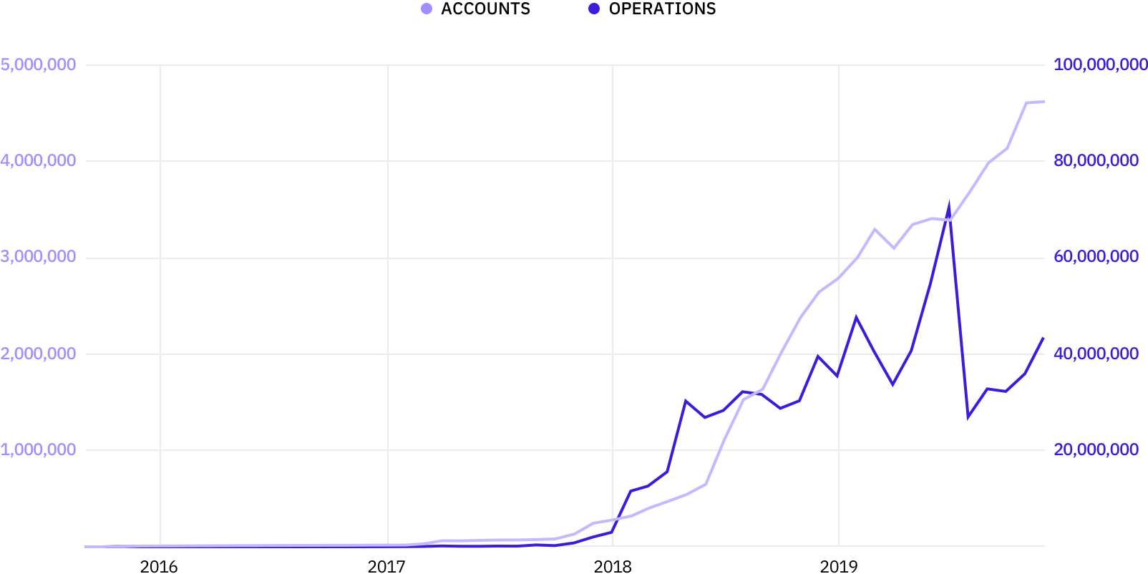
A natural, pleasant, byproduct of having a network token is that it eases the movement of money between users. Because everyone has and needs lumens, lumens can always be a medium of exchange between otherwise illiquid assets.

The lumen supply
Unlike the tokens of other blockchains, lumens aren’t mined or awarded by the protocol over time. Instead, 100 billion lumens were created when the Stellar network went live, and for the first 5 or so years of Stellar’s existence, the supply of lumens also increased by 1% annually, by design.
That inflation mechanism was ended by community vote in October 2019. And in November 2019, the overall lumen supply was reduced. Now there are about 50 billion lumens, total, in existence, and no more lumens will be created.
Nearly 20 billion lumens are out in the open market, and the Stellar Development Foundation retains the other 30 billion or so to develop and promote Stellar, per its mandate. Those lumens will enter the public markets over the next few years. Anyone who wants a complete accounting for all lumens in existence should visit our Lumen Accounting guide for detailed explanations of major lumen metrics, as well as instructions on how to calculate supply details from the ground-up using Stellar’s APIs.

How to buy and store lumens
You need lumens to use Stellar. Luckily, they’re for sale on many exchanges and available for trade directly on the Stellar network as well.
In the U.S., Coinbase and Kraken are two options for buying lumens with dollars. The native Stellar exchange, Lobstr, allows you to buy lumens directly on the network. See our longer list of lumen-supporting exchanges for more options.
Note that digital currencies can be volatile and buying them can be risky. While lumens will always have utility in the Stellar network, the price of lumens denominated in fiat currency may change, and you could lose significant value.
For storing lumens and for easy access to network features like payments and peer-to-peer sends, we recommend a hardware or digital wallet from our wallets list.

